# National University of Computer and Emerging Sciences ...

# Enterprise Resource Planner

## Sequence Diagrams

### Group Members:

|  |  |
| --- | --- |
| Ahmad Saaim | 21L-5219 |
| Reyan Ahtesham | 21L-5267 |
| Ali Nawaz | 21I-0801 |
| Minal Anwar | 21L-1848 |
| Nouman Javed | 21L-1788 |

# 1: Login Account

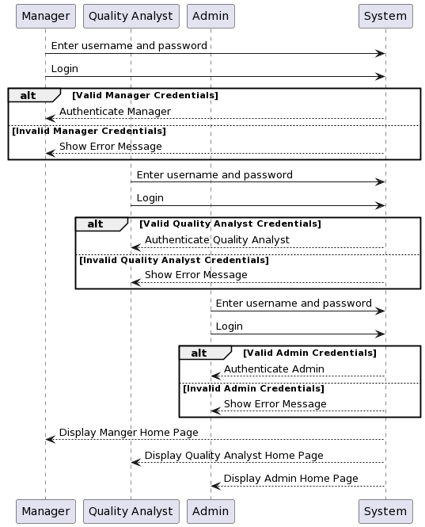

# 2: Logout Account

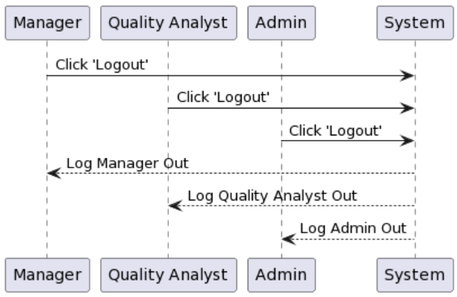

# 3: Authenticate Credentials

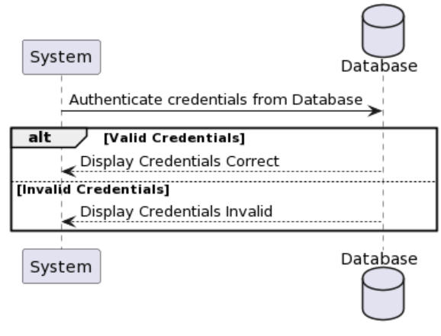

# 4: Register Account

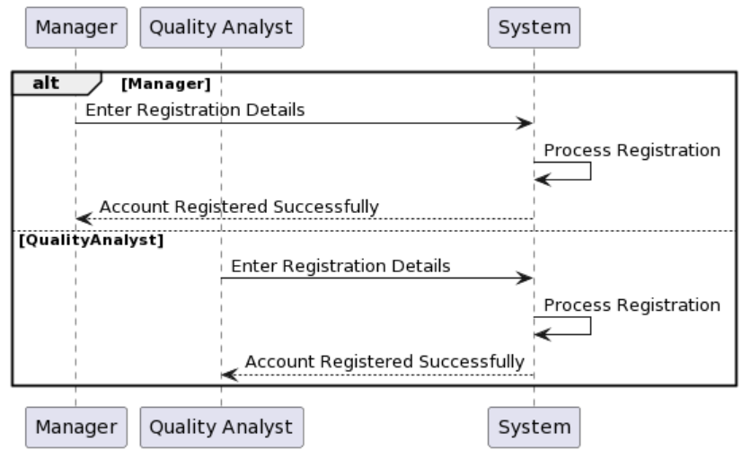

# 5: View Inventory

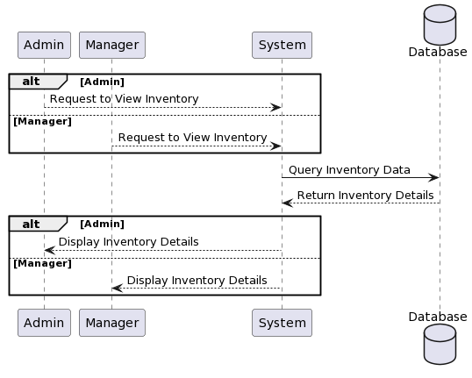

# 6: View Vendor List



# 7: View Vendor Rating

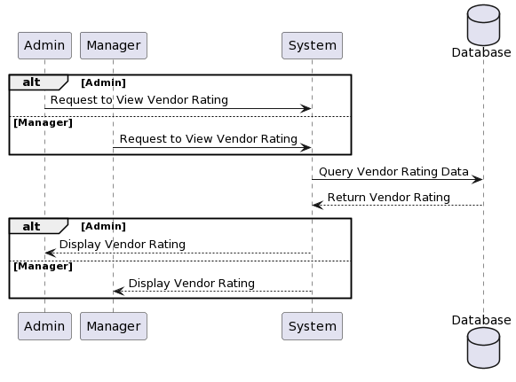

# 8: Manage Inventory

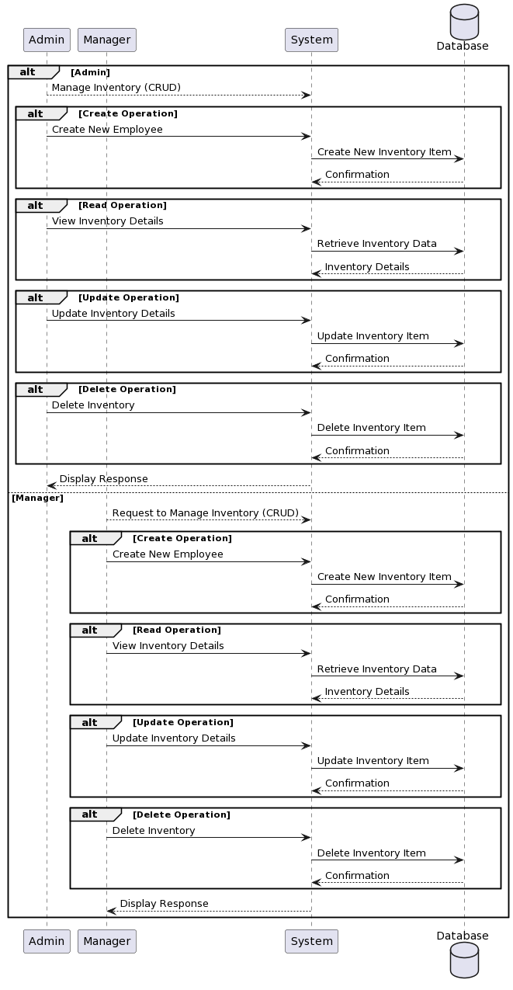

# 9: Manage Employees

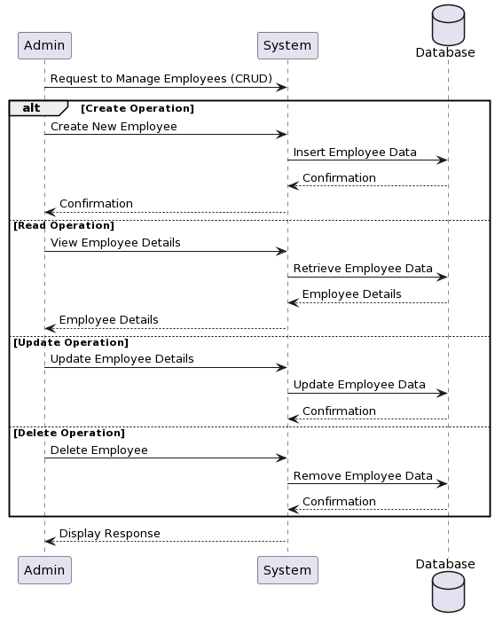

# 10: Manage Task

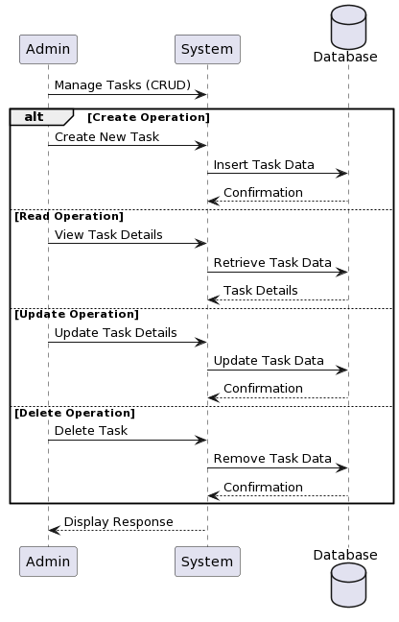

# 11: View Employees

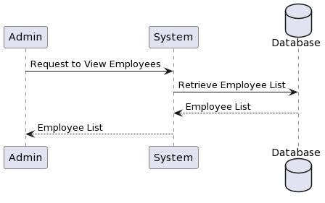

# 12: View System Statistics

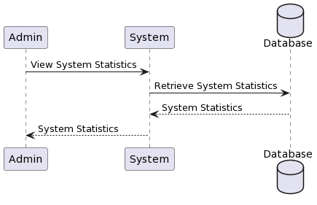

# 13: Reject Quotation

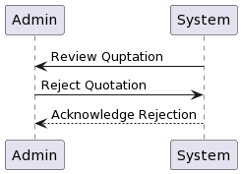

# 14: Accept Quotation

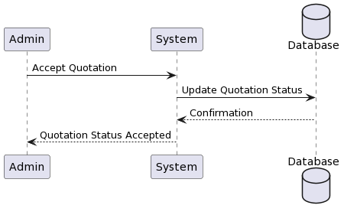

# 15: Order Items

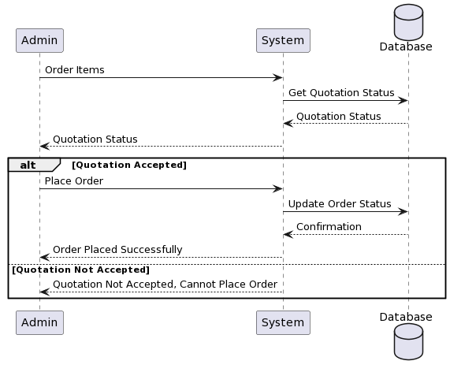

# 16: View Employee Ratings

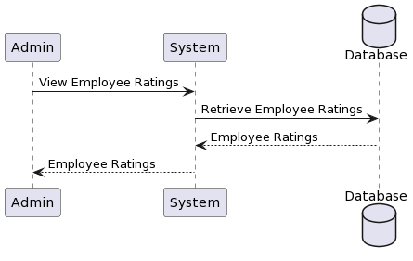

# 17: View Best Employees

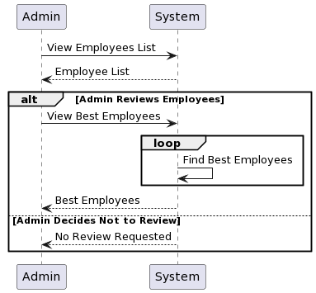

# 18: View Worst Employees

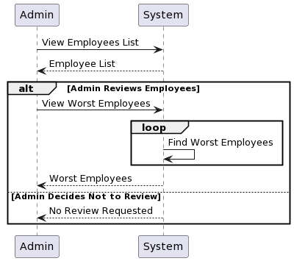

# 19: Send Quotation Approval Request

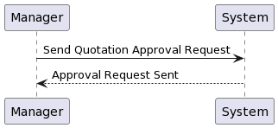

# 20: Set Vendor Rating

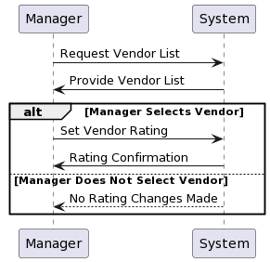

# 21: Set Vendor Rating

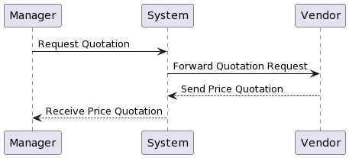

# 22: Product Quality Check

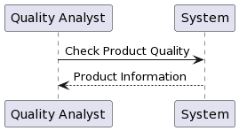

# 23: Set Employee Rating

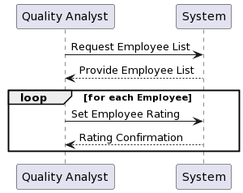

# 24: Process Payment

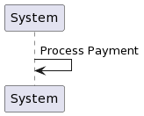

# 25: Send Notification

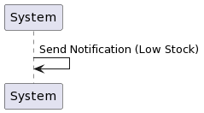

# 26: Send Automated Email to Vendor

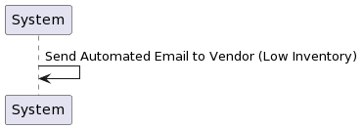

# 27: Notify Manager of Rejection

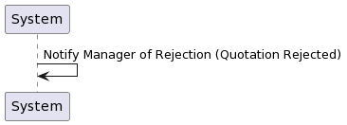

# 28: Low Materials

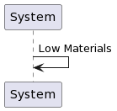

# 29: regression Analysis

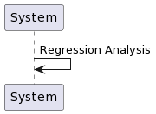

# 30: Requirement Analysis

